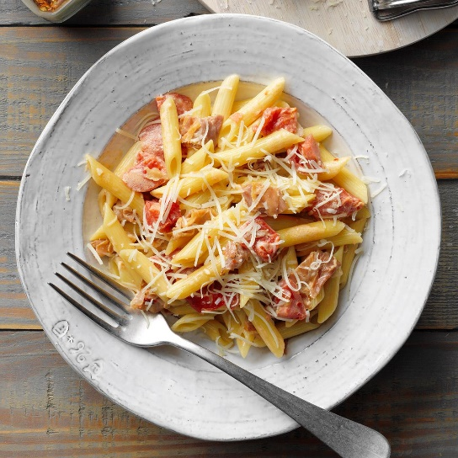
Penne alla Vodka
Prep/Total Time 30 min.
6 Servings.

Ingredients
1 package (16 ounces) penne pasta
3 Tbsp butter
2 garlic cloves, minced
4 ounces thinly sliced prosciutto, cut into strips
1 can (28 ounces) whole plum tomatoes, drained and chopped
¼ cup vodka
½ tsp salt
½ tsp crushed red pepper flakes

½ cup heavy whipping cream

Directions
- Cook pasta according to package directions.
- Meanwhile, in a large skillet, heat butter over medium-high heat. Add garlic; cook and stir 1 minute.
- Add prosciutto; cook 2 minutes longer.
- Stir in tomatoes, vodka, salt and pepper flakes. Bring to a boil.
- Reduce heat; simmer, uncovered, 5 minutes.
- Stir in cream; cook 2-3 minutes longer, stirring occasionally.
- Drain pasta. Add pasta and cheese to sauce; toss to combine.

